**Scenario: Inventory Tagging and Shipping Mechanism**

We are a big pharmaceutical company which makes medicines on assembly line. We want a very

fast system which will be deployed at different entry points of different warehouses for recording

the input of the quantity of the finished goods. We want the system to track the delivery of goods

from particular entry point. At the time of delivery of goods, the user should call an open service

to get the date + time + temperature of location and create a unique tag to mark the delivery/order.

The system should not allow the creation of tag if the service is not available. But, at the same

time we would not want the users to get blocked. So we would need a mechanism to let users

continue with other orders and the pending orders will get tagged once the service is available.

The system might be used at multiple entry points within a warehouse, so the system must be

restrictive enough to not allow users to book orders with same goods. Good performance of the

system will be a much-desired feature.

**Use Case 1**

System will be deployed at different entry points of different warehouses for recording the input

of the quantity of the finished goods

Authenticated user (Warehouse Attendant) should be able to enter the details of Goods which are

entering the warehouse**Functionality Flow**

1. **Login Page**

* Start at Login Page
* Enter User Name and Password
* User Name
* 255 char text field which needs to be filled by User
* DB-type: Alphanumeric (10 chars)
* Case Insensitive
* Mandatory Field
* Password
* 255 char text field which needs to be filled by User
* DB-type: Alphanumeric (10 chars)
* Case Insensitive
* Entry in Field should be shown as ‘*’
* Mandatory Field
* Authenticate User
* Match User Name and Password with DB values
* Authenticate Rights = ‘Warehouse Attendant, or ‘Manager’ or ‘Administrator’
* If User Name or Password is Incorrect, Provide relevant Error Message to User
* If User Name and Password are correct but Rights are not present, show Message to user and
* Redirect to Home Page
* If User is authenticated (User Name, Password and Rights) , redirect to ‘Warehouse
* Management’ page

1. **Warehouse Management Page**

* Select ‘Add Items’ from menu option (which will open Add Item form).
* Fill in the following details in the Add Item form
* Item ID:
* 255 char text field which needs to be filled by User
* Must be Unique
* DB-type: Alphanumeric (10 chars)
* Mandatory Field
* Item Description:
* 255 char text field which needs to be filled by User
* DB-type: Alphanumeric (255 chars)
* Mandatory Field
* Item Type:
* User Selects Field value from Dropdown – i.e. Medicine, Raw Material,
* Others)
* Mandatory Field
* Entry Date:
* 255 char text field which needs to be filled by User
* DB-type: Date
* Mandatory Field
* Expiry Date:
* 255 char text field which needs to be filled by User
* DB-type: Date
* Must be greater than ‘Entry Date’
* Price:
* 255 char text field which needs to be filled by User
* DB-type: Integer
* Quantity:
* 255 char text field which needs to be filled by User
* DB-type: Integer
* Mandatory Field
* If save is clicked
* If all values are correct, enter values in DB and notify user about success
* Close Add Item Form and Redirect user Warehouse Management page
* If values are incorrect, provide Error message(s) below the field(s) with incorrect

value(s)

* If Cancel is clicked
* Close Add Item Form and Redirect user Warehouse Management page

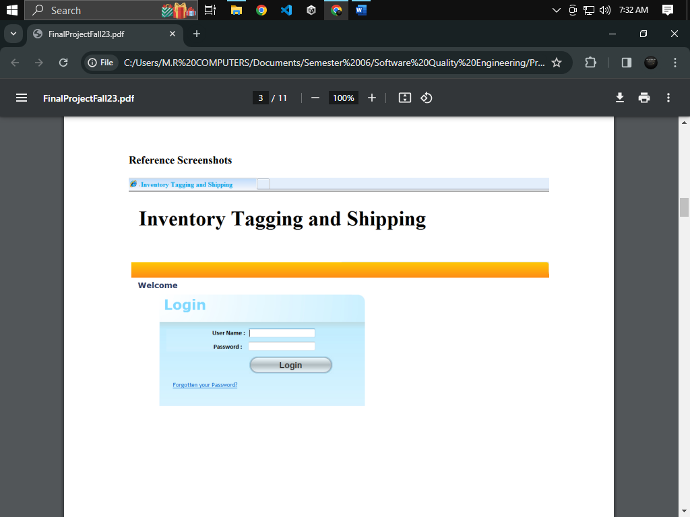

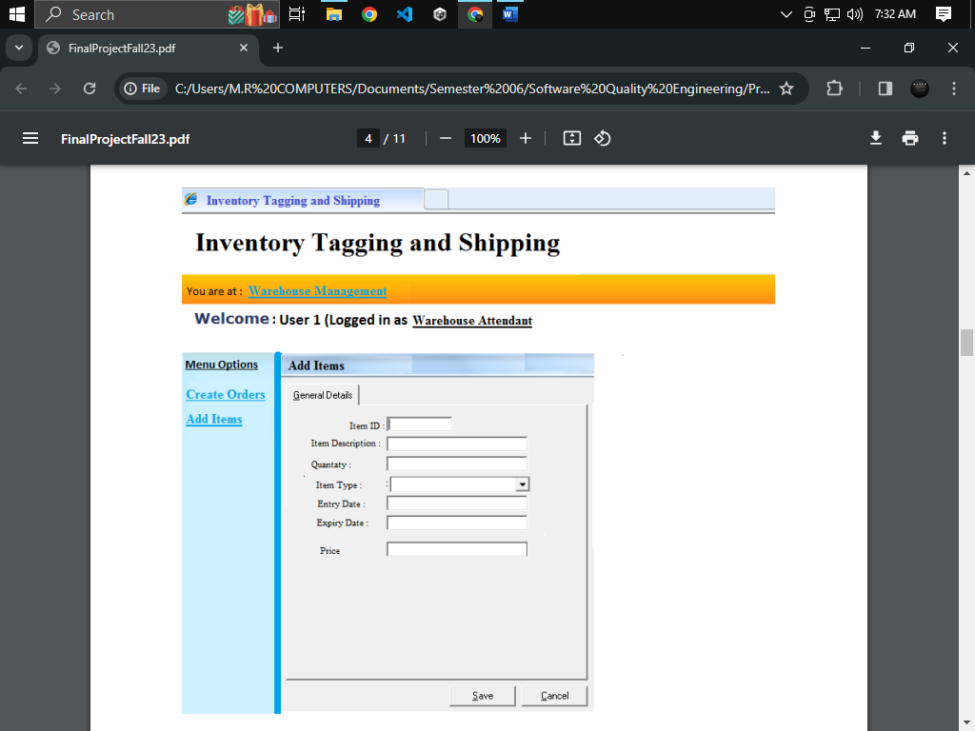

**Part A**

**1. Peer Review the Scenario and raise QA concerns (points which needs clarification from**

**QA’s perspective)**

**PEER REVIEWS:**

1. **Peer review during document review**

* Username must be at least 6 characters not 10 characters
* Password must be case sensitive and at least 8 characters
* Password must be with some validations (capital letter, small letter, number, special character, not a space)
* Add features of button for login
* Add the forgot button features
* There are many fields that can be added in the “Add item” form
* We can add item name, unit of measure, supplier information, comment (additional information)

1. **Peer review during design review**

**Login Page**

* + - The login page should not contain welcome note before not logged In
    - Yellow bar is unnecessary
    - Login box should be in center
    - Size of login button is awkward
    - login button is rounded with the appearing of border color
    - login heading is incomplete it should be like “Login to Warehouse system”
    - forgot link is not attractive because of underlined, it should be like a button

**Warehouse Page**

* yellow color is not attractive
* it is unnecessary to write “you are at:”
* “Warehouse Management” should not underline
* welcome note should not contain “:” and “logged in as”
* font inconsistency in the entire page
* form width is not 100%
* there is no padding in the sidebar headings
* dark blue line is not attractive between the sidebar and form
* fields inconsistency
* save and cancel buttons are not at the right position, first cancel than save

**Part B**

**2. Design Test Cases for the above Use Cases (Functionality Flows)**

**a. Positive Functional Test Cases**

**b. Negative Functional Test Cases**

**c. At least 2 Security Test Cases**

**system name: Invetororail System**

|  |  |  |  |  |  |  |  |  |
| --- | --- | --- | --- | --- | --- | --- | --- | --- |
| TC ID | Scenario | Pre-Requisites | Test Data | Test Steps | Expected Result | Actual Result | Status | Test Case Type |
| IS-01 | Successful Login | User account exists with the correct username, password, and rights | [valid name]  [valid password] | Navigate to login page  Enter username and password  Click the login button | User is redirected to the 'Warehouse Management' page. |  |  | Positive Functional |
| IS-02 | Incorrect Login Credentials | User account exists but with incorrect username or password | [invalid name]  [invalid password] | Navigate to login page  Enter username and password  Click the login button | System displays an error message indicating incorrect credentials. |  |  | Negative Functional |
| IS-03 | Access 'Add Items' without Rights | User has logged in but does not have 'Add Items' rights | [restricted_user]  [valid] | Successful login with restricted user  And navigate to add item page | System displays an error message and denies access to 'Add Items'. |  |  | Security |
| IS-04 | Add Item with Valid Data | User has the necessary rights and is on the 'Warehouse Management' page | Item ID: unique_id, Description:  [valid], Type: Medicine, Entry Date: [valid], Expiry Date: [valid], Price: 100, Quantity: 10 | 1. Click on 'Add Items'. 2. Fill in all the required fields with valid data.  3. Click on 'Save'. | Item is added to the database, and the user is redirected to the 'Warehouse Management' page with a success message. |  |  | Positive Functional |
| IS-05 | Add Item with Invalid Expiry Date | User has the necessary rights and is on the 'Warehouse Management' page | Item ID: unique_id, Description:  [valid], Type: Medicine, Entry Date: [valid], Expiry Date: [invalid], Price: 100, Quantity: 10 | 1. Click on 'Add Items'. 2. Fill in all the required fields with invalid expiry date.  3. Click on 'Save'. | System displays an error message for the invalid expiry date, and the item is not added to the database. |  |  | Negative Functional |
| IS-06 | Attempt to Save Form with Blank Mandatory Field | User has the necessary rights and is on the 'Warehouse Management' page | Item ID: unique_id, Description:  [valid], Type: Medicine, Entry Date: [valid], Expiry Date: [valid], Price: 100, Quantity: blank | 1. Click on 'Add Items'. 2. Leave a mandatory field blank.  3. Click on 'Save'. | System displays an error message for the blank field, and the item is not added to the database. |  |  | Negative Functional |
| IS-07 | Attempt to Save Form with Existing Item ID | User has the necessary rights and is on the 'Warehouse Management' page | Existing item with ID: existing_id, Description: existing_desc, Type: Raw Material, Entry Date: existing_date, Expiry Date: existing_date, Price: 50, Quantity: 20 | 1. Click on 'Add Items'. 2. Enter an item ID that already exists. 3. Click on 'Save'. | System displays an error message for the duplicate item ID, and the item is not added to the database. |  |  | Negative Functional |
| IS-08 | Attempt to Save Form with Invalid Characters in Price | User has the necessary rights and is on the 'Warehouse Management' page | Item ID: unique_id, Description: [valid], Type: Medicine, Entry Date: [valid], Expiry Date: [valid], Price: [invalid], Quantity: 10 | 1. Click on 'Add Items'. 2. Enter invalid characters in the price field. 3. Click on 'Save'. | System displays an error message for the invalid price characters, and the item is not added to the database. |  |  | Negative Functional |
| IS-09 | An unauthorized user directly accesses the page of management without logging | The user has not logged in | N/A | 1. Open a new browser window in incognito mode  2. Enter the URL of the 'Warehouse Management' page directly without logging in.  3. Press Enter to navigate to the page. | The system should redirect the user to the login page and deny access to the 'Warehouse Management' page, |  |  | Security |

**Part C**

**3. You have received the first build of the application. Following is the result of actual**

**application behavior when you performed the following actions:**

**a. Logged in using valid User credentials (of Warehouse Manager)**

**b. On “Warehouse Management” page, clicked on “Add Item”**

**c. On Add Item form, click SAVE without entering any value**

**d. Same steps are done on “Create Orders”**

**Bug Reporting for login Page**

**Bug#01**

**Title:**

UI Aesthetic Issues with Button Appearance: Size

**Severity:**

Minor

**Priority:**

Low

**Environment:**

Web Application Version: 2.1.0

Browser: Google Chrome 96.0.4664.110

Operating System: Windows 10

**Description:**

The button functionality is working correctly, but its appearance does not align with a professional design standard.

**Steps to reproduce:**

Step 1: Navigate to [Page/Section] where the button is located.

Step 2: Locate the button with the following characteristics: large size, dark color, undesirable margin.

**Actual Result:**

The button is observed to have the Excessive size issues:

**Expected Result:**

The button should have a professional appearance in terms of size, color, and margin, aligning with the overall design standards.

**Attachment:**

**Additional Information:**

The button functionality is working correctly, but its appearance does not align with a professional design standard.

**Bug#02**

**Title**:

Styling and Alignment Issues with 'Forgot' Button

**Severity:**

Minor

**Priority:**

Low

**Environment:**

Web Application Version: 2.1.0

Browser: Google Chrome 96.0.4664.110

Operating System: Windows 10

**Description:**

The "Forgot" button, intended for password recovery, is exhibiting alignment and styling issues. Specifically, the button is underlined, deviating from the design standard.

**Steps to reproduce:**

Step 1: Navigate to the login or password recovery page.

Step 2: Locate the "Forgot" button.

**Actual Result:**

The "Forgot" button exhibits the following issues:

1. Underlined text
2. Misalignment with other buttons
3. Inconsistent color (appearing as blue)

**Expected Result:**

The "Forgot" button should follow the established design standards, with consistent alignment, no underlining, and a color

**Attachment:**

**Additional Information:**

The "Forgot" button, intended for password recovery, is exhibiting alignment and styling issues. Specifically, the button is underlined, deviating from the design standard.

**Bug#03**

**Title:**

Update Login Label to Include Application Name

**Severity:**

Minority

**Priority:**

Low

**Environment:**

Web Application Version: 2.1.0

Browser: Google Chrome 96.0.4664.110

Operating System: Windows 10

**Description:**

The label simply states "Login" without mentioning the specific application name. It should be updated to "Login to warehouse system for clarity and user context.

**Steps to reproduce:**

* 1. Open the login page of the application.

**Actual Result:**

The label on the login page simply states "Login" without mentioning the application name.

**Expected Result:**

The label on the login page should read "Login to [Your Application Name]" for enhanced user clarity.

**Attachment:**

**Additional Information:**

The label simply states "Login" without mentioning the specific application name. It should be updated to "Login to warehouse system for clarity and user context.

**Bug#04**

**Title:**

Login Box Width and Positioning Issues on 100% Page

**Severity:**

Minority

**Priority:**

Low

**Environment:**

Web Application Version: 2.1.0

Browser: Google Chrome 96.0.4664.110

Operating System: Windows 10

**Description:**

On the page, the overall width is set to 100%, but the login box does not follow suit. It fails to extend to 100% width, and its positioning is off-center.

**Steps to reproduce:**

1. Open the page with the login box.

**Actual Result:**

The login box fails to extend to 100% width, is not centered on the page, and does not have a height of 100vh.

**Expected Result:**

The login box should extend to 100% width, be centered on the page, and have a height of 100vh for visual consistency.

**Attachment:**

**Additional Information:**

On the page, the overall width is set to 100%, but the login box does not follow suit. It fails to extend to 100% width, and its positioning is off-center.

**Bug#05**

**Title:**

Color Shade Inconsistency Across Application

**Severity:**

Minority

**Priority:**

Low

**Environment:**

Web Application Version: 2.1.0

Browser: Google Chrome 96.0.4664.110

Operating System: Windows 10

**Description:**

The application exhibits a color shade issue, affecting the visual consistency of certain elements

**Steps to reproduce:**

1. Navigate to login page

**Actual Result:**

Colors are observed to be inconsistent, deviating from the established design standards, and causing a visual discrepancy.

**Expected Result:**

Colors across the application should be consistent, adhering to the established design palette.

**Attachment:**

**Additional Information:**

The application exhibits a color shade issue, affecting the visual consistency of certain elements

1. **Bug Reporting for Add Items Page**

**Bug#01**

**Title:**

Padding and Margin Issues with Sidebar on “Add item” page

**Severity:**

Minority

**Priority:**

Low

**Environment:**

Web Application Version: 2.1.0

Browser: Google Chrome 96.0.4664.110

Operating System: Windows 10

**Description:**

There are padding and margin issues with the sidebar. The spacing around the sidebar elements is not consistent, affecting the overall layout and visual harmony.

**Steps to reproduce:**

1. Log in as a manager and navigate to the manager's page.

**Actual Result:**

There are inconsistencies in the padding and margin around the sidebar elements, leading to a lack of visual harmony on the manager's page.

**Expected Result:**

The sidebar elements should have consistent padding and margin, ensuring a visually balanced layout.

**Attachment:**

**Additional Information:**

There are padding and margin issues with the sidebar. The spacing around the sidebar elements is not consistent, affecting the overall layout and visual harmony.

**Bug#02**

**Title:**

Aesthetic Issues with Underlined Words in Warehouse Attendee Login

**Severity:**

Minority

**Priority:**

Low

**Environment:**

Web Application Version: 2.1.0

Browser: Google Chrome 96.0.4664.110

Operating System: Windows 10

**Description:**

The user login experience for the warehouse manager role has aesthetic issues, specifically with the underlined words, impacting the overall visual appeal.

**Steps to reproduce:**

1. Log in as a warehouse manager and observe the login experience.

**Actual Result:**

The current presentation of underlined words during the warehouse manager login process affects the visual appeal negatively.

**Expected Result:**

The login experience for the warehouse manager role should be visually appealing, with underlined words enhancing rather than detracting from the overall appeal.

**Attachment:**

**Additional Information:**

The user login experience for the warehouse manager role has aesthetic issues, specifically with the underlined words, impacting the overall visual appeal.

**Bug#03**

**Title:**

Unexpected Blue Line Between 'Add Item' Form and Sidebar

**Severity:**

Minority

**Priority:**

Low

**Environment:**

Web Application Version: 2.1.0

Browser: Google Chrome 96.0.4664.110

Operating System: Windows 10

**Description:**

There is an unexpected blue line appearing between the "Add Item" form and the sidebar on the application page.

**Steps to reproduce:**

1. Log in as a warehouse manager and observe the login experience.

**Actual Result:**

An unexpected blue line is visible between the "Add Item" form and the sidebar, causing a visual disruption.

**Expected Result:**

There should not be any visible blue line between the "Add Item" form and the sidebar. The layout should appear seamless and without any unexpected visual elements.

**Attachment:**

**Additional Information:**

There is an unexpected blue line appearing between the "Add Item" form and the sidebar on the application page.

**Bug#04**

**Title:**

Incorrect Placement of 'Save' and 'Cancel' Buttons

**Severity:**

Minority

**Priority:**

Low

**Environment:**

Web Application Version: 2.1.0

Browser: Google Chrome 96.0.4664.110

Operating System: Windows 10

**Description:**

The placement of the "Save" and "Cancel" buttons is incorrect; they should be exchanged for better usability. Currently, the "Save" button is on the left side, and the "Cancel" button is on the right side.

**Steps to reproduce:**

1. Access the page with the "Save" and "Cancel" buttons.

**Actual Result:**

The current placement of the "Save" and "Cancel" buttons is reversed, with the "Save" button on the left side and the "Cancel" button on the right side.

**Expected Result:**

The "Save" button should be on the right side, providing a convenient position for users to save data to the database. The "Cancel" button should be on the left side.

**Attachment:**

**Additional Information:**

The placement of the "Save" and "Cancel" buttons is incorrect; they should be exchanged for better usability. Currently, the "Save" button is on the left side, and the "Cancel" button is on the right side.

**Bug#05**

**Title:**

Font Inconsistency Across Application

**Severity:**

Minority

**Priority:**

Low

**Environment:**

Web Application Version: 2.1.0

Browser: Google Chrome 96.0.4664.110

Operating System: Windows 10

**Description:**

There is a font inconsistency issue within the application, impacting the overall visual coherence.

**Steps to reproduce:**

1. Navigate through different sections or elements within the application.

**Actual Result:**

Different fonts are observed across various sections or elements, leading to inconsistency in the application's visual presentation.

**Expected Result:**

The font used across the application should be consistent, providing a uniform and visually appealing user interface.

**Attachment:**

**Additional Information:**

There is a font inconsistency issue within the application, impacting the overall visual coherence.

**Bug#06**

**Title:**

Unnecessary Welcome Note Displayed in Application

**Severity:**

Minor

**Priority:**

Low

**Environment:**

Web Application Version: 2.1.0

Browser: Google Chrome 96.0.4664.110

Operating System: Windows 10

**Description:**

There is an unnecessary or redundant welcome note displayed within the application,

**Steps to reproduce:**

1. Access the application or specific section where the unnecessary welcome note is displayed

**Actual Result:**

An unnecessary or redundant welcome note is displayed within the application, potentially causing confusion or clutter.

**Expected Result:**

The welcome note, if present, should be relevant and necessary for user engagement. There should not be any redundant or unnecessary welcome messages.

**Attachment:**

**Additional Information:**

There is an unnecessary or redundant welcome note displayed within the application,

**Part D**

**4. Provide 3 suggestions regarding “Usability” aspect for each page (i.e. suggest 3 things in**

**each page that should be implemented for good User Experience)**

* **usability for login page**
  + User can login with the embedded account like Google
  + Give the placeholder in the fields and show the validations below the fields and at real time when user is providing the credentials
  + Give the title of login like login as manager, administrator or attendance
  + Selection option before logging (manager or administrator).
  + Remember option should be appear to easily logging the page.
* **usability for warehouse page**
  + Provide Real-time Validation and Error Feedback
  + Autocomplete suggestions
  + Pop up the confirmation screen before send data to database with edit functionality.
  + Drop down options to select the product or other option to easily enter data

Use Case 2

At the time of delivery of goods, the user should call an open service to get the

date + time + temperature of location and create a unique tag to mark the delivery/order.

The system will be used at multiple entry points within a warehouse, so the system not allow

users to book orders with same goods

**Functionality Flow**

* 1. **Login Page**
* Start at Login Page
* Enter User Name and Password
  + User name
    - 255 char text field which needs to be filled by User
    - DB-type: Alphanumeric (10 chars)
    - Case Insensitive
    - Mandatory Field
  + Password
    - 255 char text field which needs to be filled by User
    - DB-type: Alphanumeric (10 chars)
    - Case Insensitive
    - Entry in Field should be shown as ‘*’
    - Mandatory Field
  + Authenticate User
    - Match User Name and Password with DB values
    - Authenticate Rights = ‘Warehouse Manager’ or ‘Administrator’
  + If User Name or Password is Incorrect, Provide relevant Error Message to User
  + If User Name and Password are correct but Rights are not present, show Message to user and
  + Redirect to Home Page
  + If User is authenticated (User Name, Password and Rights) , redirect to ‘Warehouse
  + Management’ page
  1. **Warehouse Management Page**
* Select ‘Add Orders’ from menu option (which will open Create Order form).
* When Create Order is selected, at backend, the application calls 2 Open Web-services
  + First WS to obtain current Date+Time (i.e. DD-HH)
  + Second WS to obtain Temperature (i.e. TT)
* Creation of a Unique Tag
  + At backend, another custom (self-created) WS is invoked which performs following actions
    - Concatenate “Date-Time-Temperature”
    - Create a 6-digit random number “NNNNNN” using Randomize function
    - Concatenate both items i.e. “DD-HH-TT-NNNNNN”
    - Save this in DB table “Order Record” under Column “Next Tag”
* If any of the above step Fails, show message to User: “Cannot create an Order since Tag is Not Available”
* if the above 2 steps are successful, Open “Create Order” form
* Fill in the following details in the Create Order form
  + Order tag
    - Fetch value from DB table “Order Record” under Column “Next Tag”
    - Field must be disabled and non-editable
  + Order description
    - 255 char text field which needs to be filled by User
    - DB-type: Alphanumeric (255 chars)
    - Mandatory Field
  + Customer ID
    - 255 char text field which needs to be filled by User
    - DB-type: Alphanumeric (255 chars)
    - Mandatory Field
    - Case Insensitive
    - ID Must exist in DB (under DB Table “Customer” column: “ID”)
  + Items ID (3 items)
    - 255 char text field which needs to be filled by User
    - Must be Unique
    - DB-type: Alphanumeric (10 chars)
    - Mandatory Field
  + Quantity (against each item ID)
    - 255 char text field which needs to be filled by User
    - DB-type: Integer
    - Mandatory Field
  + Order Date
    - 255 char text field which needs to be filled by User
    - DB-type: Date
    - Mandatory Field
  + Dispatch Date
    - 255 char text field which needs to be filled by User
    - DB-type: Date
    - Must be greater than ‘Entry Date’
  + Price
    - 255 char text field which needs to be filled by User
    - DB-type: Integer
* If save is clicked
  + Check that Quantity for each Item ID listed is present in Warehouse (fetch and compare value from Column “Total Quantity” against Item ID from DB table “Items”)
  + Check that sum of Quantities of parallel Orders with same Item IDs listed are not exceeding the Total Quantity present in Warehouse
    - Fetch all Orders currently Open, and narrow on Orders with same Item IDs as in this current Order
    - Sum all Quantities and compare with value from Column “Total Quantity” against each Item ID from DB table “Items
  + If any of the above step Fails, provide message to User: “Cannot Create Order. Order exceeds Quantity available in Warehouse”
  + If all values are correct, enter values in DB and notify user about success
    - Close Create Order Form and Redirect user Warehouse Management page
  + If values are incorrect, provide Error message(s) below the field(s) with incorrect value(s)
* If Cancel is clicked
  + Close Create Order Form and Redirect user Warehouse Management page

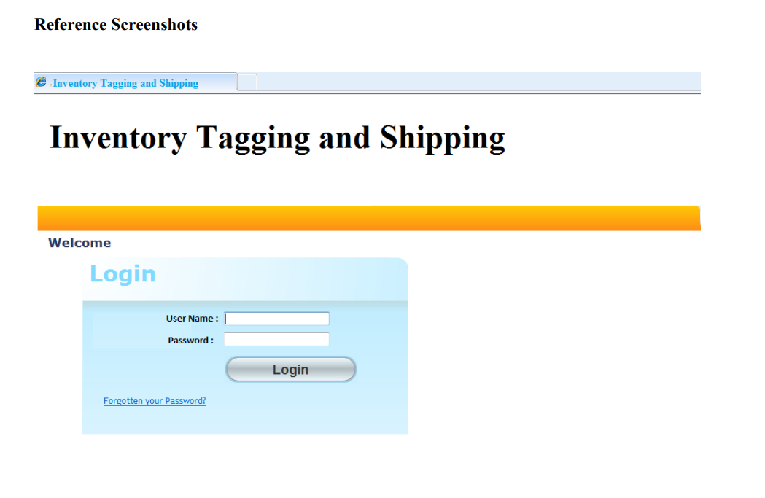

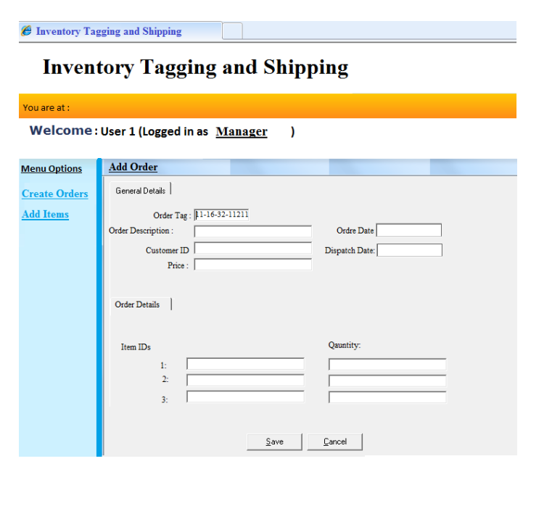

**Part A**

**Peer Review the Scenario and raise QA concerns (points which needs clarification from**

**QA’s perspective)**

**PEER REVIEWS:**

1. **Peer review during document review**
   * Username must be at least 6 characters not 10 characters
   * Password must be case sensitive and at least 8 characters
   * Password must be with some validations (capital letter, small letter, number, special character, not a space)
   * Add features of button for login
   * Add the forgot button function
   * If any one of the services is failed that we couldn’t stop create order process because our system should be reliable but stop the process if tag is not available
   * Customer ID should be case sensitive and at least 8 characters long
   * For item ID there should be a format like TMO-0001
   * In price there should be validations like price>$19
2. **Peer review during design review**

**Login Page**

* The login page should not contain welcome note before not logged In
* Yellow bar is unnecessary
* Login box should be in center
* Size of login button is awkward
* login button is rounded with the appearing of border color
* login heading is incomplete it should be like “Login to Warehouse system”
* forgot link is not attractive because of underlined, it should be like a button

**Warehouse Page (Create Order)**

* yellow color is not attractive
* it is unnecessary to write “you are at:”
* “Add Items” should not underline
* welcome note should not contain “:” and “logged in as”
* font inconsistency in the entire page
* form width is not 100%
* there is no padding in the sidebar headings
* dark blue line is not attractive between the sidebar and form
* fields inconsistency
* color palette is not good
* fields and inputs are not aligned
* save and cancel buttons are not at the right position, first cancel than save
* buttons should be at right bottom not in center

**Part B**

**2. Design Test Cases for the above Use Cases (Functionality Flows)**

**a. Positive Functional Test Cases**

**b. Negative Functional Test Cases**

**c. At least 2 Security Test Cases**

**Test cases for the login page**

**Positive Test Cases**

|  |  |  |  |  |  |  |  |
| --- | --- | --- | --- | --- | --- | --- | --- |
| TC ID | Scenario | Pre-requisites | Test Data | Test Steps | Expected Result | Actual Result | status |
| IS-01 | Successful Login | User account exists in the database | Valid username and password | Enter valid credentials and click Login | Redirect to Warehouse Management |  |  |
| IS-02 | Successful Order Creation | User is logged in and has rights | Valid order details, available items, and customer ID | Click on "Add Orders" -> Fill in valid details -> Click Save | Order is created successfully, and the user is redirected to the Warehouse Management |  |  |
| IS-03 | Unique Order Tag Generation | User is logged in | Valid order details | Create an order and verify the generated order tag in the Order Record table | Order tag is unique and follows the format "DD-HH-TT-NNNNNN" |  |  |
| IS-04 | Valid Quantity Check | Items with sufficient quantity are present in the warehouse | Valid order details | Create an order with valid quantities | Order is created successfully, and the user is redirected to the Warehouse Management page |  |  |

**Negative Test Cases**

|  |  |  |  |  |  |  |  |
| --- | --- | --- | --- | --- | --- | --- | --- |
| TC ID | Scenario | Pre-requisites | Test Data | Test Steps | Expected Result | Actual Result | **Status** |
| IS-01 | Incorrect Login | User account does not | Invalid username or password | Enter invalid credentials and click Login | Display relevant error message |  |  |
| IS-02 | Duplicate Order Tag | Order tag already exists in the Order Record table | Valid order details | Attempt to create an order with the same tag | Display error message "Cannot create an Order since Tag is Not Available" |  |  |
| IS-03 | Invalid Item ID | Item ID does not exist in the Items | Invalid item ID | Create an order with an invalid item ID | Display error message below the Item ID field |  |  |
| IS-04 | Invalid Item ID | Quantity in the order exceeds the available quantity in the warehouse | Valid order details | Create an order with quantities exceeding warehouse limits | Display error message "Cannot Create Order. Order exceeds Quantity available in Warehouse" |  |  |

**Security Test Cases**

|  |  |  |  |  |  |  |  |
| --- | --- | --- | --- | --- | --- | --- | --- |
| TC ID | Scenario | Pre-requisites | Test Data | Test steps | expected result | actual Result | status |
| IS-01 | SQL Injection | User attempts to inject SQL queries | Malicious input in the username or password | Enter malicious input and click Login | System rejects the input and displays an error message |  |  |
| IS-02 | Unauthorized Access | User without Warehouse Manager or Administrator rights | Valid username and password | Attempt to access Warehouse Management page | Display error message and redirect to the Login page |  |  |

**Part C**

**3. You have received the first build of the application. Following is the result of actual**

**application behavior when you performed the following actions:**

**a. Logged in using valid User credentials (of Warehouse Manager)**

**b. On “Warehouse Management” page, clicked on “Add Item”**

**c. On create order, click SAVE without entering any value**

**Perform UI testing on these pages and Report as many defects as possible**

**(Use given Defect Template)**

**Bug Reporting for login Page**

All bugs are reported in use case 01

**Bug Reporting for Add Items Page**

**Bug#01**

**Title:**

Padding and Margin Issues with Sidebar on “Add item” page

**Severity:**

Minority

**Priority:**

Low

**Environment:**

Web Application Version: 2.1.0

Browser: Google Chrome 96.0.4664.110

Operating System: Windows 10

**Description:**

There are padding and margin issues with the sidebar. The spacing around the sidebar elements is not consistent, affecting the overall layout and visual harmony.

**Steps to reproduce:**

1. Log in as a manager and navigate to the manager's page.

**Actual Result:**

There are inconsistencies in the padding and margin around the sidebar elements, leading to a lack of visual harmony on the manager's page.

**Expected Result:**

The sidebar elements should have consistent padding and margin, ensuring a visually balanced layout.

**Attachment:**

**Additional Information:**

There are padding and margin issues with the sidebar. The spacing around the sidebar elements is not consistent, affecting the overall layout and visual harmony.

**Bug#02**

**Title:**

Aesthetic Issues with Underlined Words in Warehouse Attendee Login

**Severity:**

Minority

**Priority:**

Low

**Environment:**

Web Application Version: 2.1.0

Browser: Google Chrome 96.0.4664.110

Operating System: Windows 10

**Description:**

The user login experience for the warehouse manager role has aesthetic issues, specifically with the underlined words, impacting the overall visual appeal.

**Steps to reproduce:**

1. Log in as a warehouse manager and observe the login experience.

**Actual Result:**

The current presentation of underlined words during the warehouse manager login process affects the visual appeal negatively.

**Expected Result:**

The login experience for the warehouse manager role should be visually appealing, with underlined words enhancing rather than detracting from the overall appeal.

**Attachment:**

**Additional Information:**

The user login experience for the warehouse manager role has aesthetic issues, specifically with the underlined words, impacting the overall visual appeal.

**Bug#03**

**Title:**

Unexpected Blue Line Between 'Add Item' Form and Sidebar

**Severity:**

Minority

**Priority:**

Low

**Environment:**

Web Application Version: 2.1.0

Browser: Google Chrome 96.0.4664.110

Operating System: Windows 10

**Description:**

There is an unexpected blue line appearing between the "Add Item" form and the sidebar on the application page.

**Steps to reproduce:**

1. Log in as a warehouse manager and observe the login experience.

**Actual Result:**

An unexpected blue line is visible between the "Add Item" form and the sidebar, causing a visual disruption.

**Expected Result:**

There should not be any visible blue line between the "Add Item" form and the sidebar. The layout should appear seamless and without any unexpected visual elements.

**Attachment:**

**Additional Information:**

There is an unexpected blue line appearing between the "Add Item" form and the sidebar on the application page.

**Bug#04**

**Title:**

Incorrect Placement of 'Save' and 'Cancel' Buttons

**Severity:**

Minority

**Priority:**

Low

**Environment:**

Web Application Version: 2.1.0

Browser: Google Chrome 96.0.4664.110

Operating System: Windows 10

**Description:**

The placement of the "Save" and "Cancel" buttons is incorrect; they should be exchanged for better usability. Currently, the "Save" button is on the left side, and the "Cancel" button is on the right side.

**Steps to reproduce:**

1. Access the page with the "Save" and "Cancel" buttons.

**Actual Result:**

The current placement of the "Save" and "Cancel" buttons is reversed, with the "Save" button on the left side and the "Cancel" button on the right side.

**Expected Result:**

The "Save" button should be on the right side, providing a convenient position for users to save data to the database. The "Cancel" button should be on the left side.

**Attachment:**

**Additional Information:**

The placement of the "Save" and "Cancel" buttons is incorrect; they should be exchanged for better usability. Currently, the "Save" button is on the left side, and the "Cancel" button is on the right side.

**Bug#05**

**Title:**

Font Inconsistency Across Application

**Severity:**

Minority

**Priority:**

Low

Environment:

Web Application Version: 2.1.0

Browser: Google Chrome 96.0.4664.110

Operating System: Windows 10

**Description:**

There is a font inconsistency issue within the application, impacting the overall visual coherence.

**Steps to reproduce:**

1. Navigate through different sections or elements within the application.

**Actual Result:**

Different fonts are observed across various sections or elements, leading to inconsistency in the application's visual presentation.

**Expected Result:**

The font used across the application should be consistent, providing a uniform and visually appealing user interface.

**Attachment:**

**Additional Information:**

There is a font inconsistency issue within the application, impacting the overall visual coherence.

**Bug#06**

**Title:**

Unnecessary Welcome Note Displayed in Application

**Severity:**

Minor

**Priority:**

Low

**Environment:**

Web Application Version: 2.1.0

Browser: Google Chrome 96.0.4664.110

Operating System: Windows 10

**Description:**

There is an unnecessary or redundant welcome note displayed within the application,

**Steps to reproduce:**

1. Access the application or specific section where the unnecessary welcome note isdisplayed

**Actual Result:**

An unnecessary or redundant welcome note is displayed within the application, potentially causing confusion or clutter.

**Expected Result:**

The welcome note, if present, should be relevant and necessary for user engagement. There should not be any redundant or unnecessary welcome messages.

**Attachment:**

**Additional Information:**

There is an unnecessary or redundant welcome note displayed within the application,

**Bug#07**

**Title:**

Inconsistency in Fields Across Application

**Severity:**

Minority

**Priority:**

Low

**Description:**

The application has inconsistencies in the fields, leading to a lack of uniformity across different sections or forms. These inconsistencies might include variations in field labels, input styles, or required field indicators.

**Environment:**

Web Application Version: 2.1.0

Browser: Google Chrome 96.0.4664.110

Operating System: Windows 10

**Steps to Reproduce:**

1. Navigate through different sections or forms within the application.

**Actual Result:**

Inconsistencies are observed in fields, labels, or input styles across different sections or forms, leading to a lack of uniformity.

**Expected Result:**

Fields, labels, and input styles should be consistent across various sections or forms, providing a standardized and user-friendly experience.

**Attachment:**

**Additional Information:**

The application has inconsistencies in the fields, leading to a lack of uniformity across different sections or forms. These inconsistencies might include variations in field labels, input styles, or required field indicators.

**Bug#08**

**Title:**

Unnecessary Yellow Bar in Application Interface

**Severity:**

Minority

**Priority:**

Low

**Description:**

An unnecessary yellow bar is observed at the top of the application interface, affecting the visual aesthetics and potentially causing distraction for users.

**Environment:**

Web Application Version: 2.1.0

Browser: Google Chrome 96.0.4664.110

Operating System: Windows 10

**Steps to Reproduce:**

1. Open the application interface.

**Actual Result:**

An unnecessary yellow bar is visible at the top of the application interface, impacting the overall visual appeal.

**Expected Result:**

The application interface should not have any unnecessary or distracting elements, such as a yellow bar at the top.

**Attachment:**

**Additional Information:**

An unnecessary yellow bar is observed at the top of the application interface, affecting the visual aesthetics and potentially causing distraction for users.

**Part D**

**4. Provide 3 suggestions regarding “Usability” aspect for each page (i.e., suggest 3 things in**

**each page that should be implemented for good User Experience)**

* **usability for login page**
* User can login with the embedded account like Google
* Give the placeholder in the fields and show the validations below the fields and at real time when user is providing the credentials
* Give the title of login like login as manager, administrator or attendance
* Selection option before logging (manager or administrator).
* Remember option should be appear to easily logging the page.
* **usability for warehouse page**
* Provide Real-time Validation and Error Feedback
* Autocomplete suggestions
* Pop up the confirmation screen before confirming order
* Drop down options to select the product or other option to easily enter data